1. 
2. You need two things to create an account
   1. Personal details with an address.
   2. Credit/Debit Card (even for free account)
3. 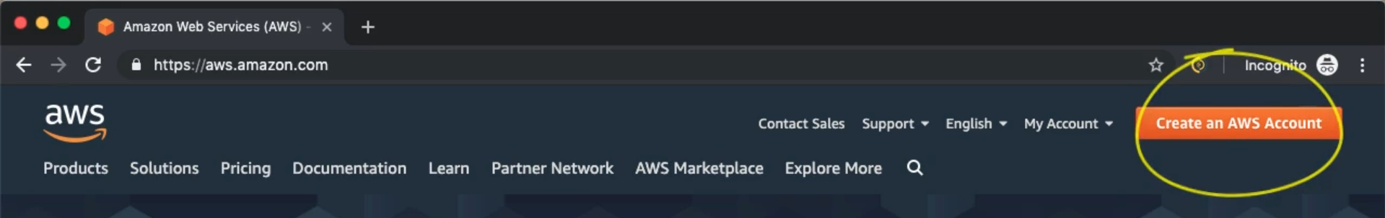
4. 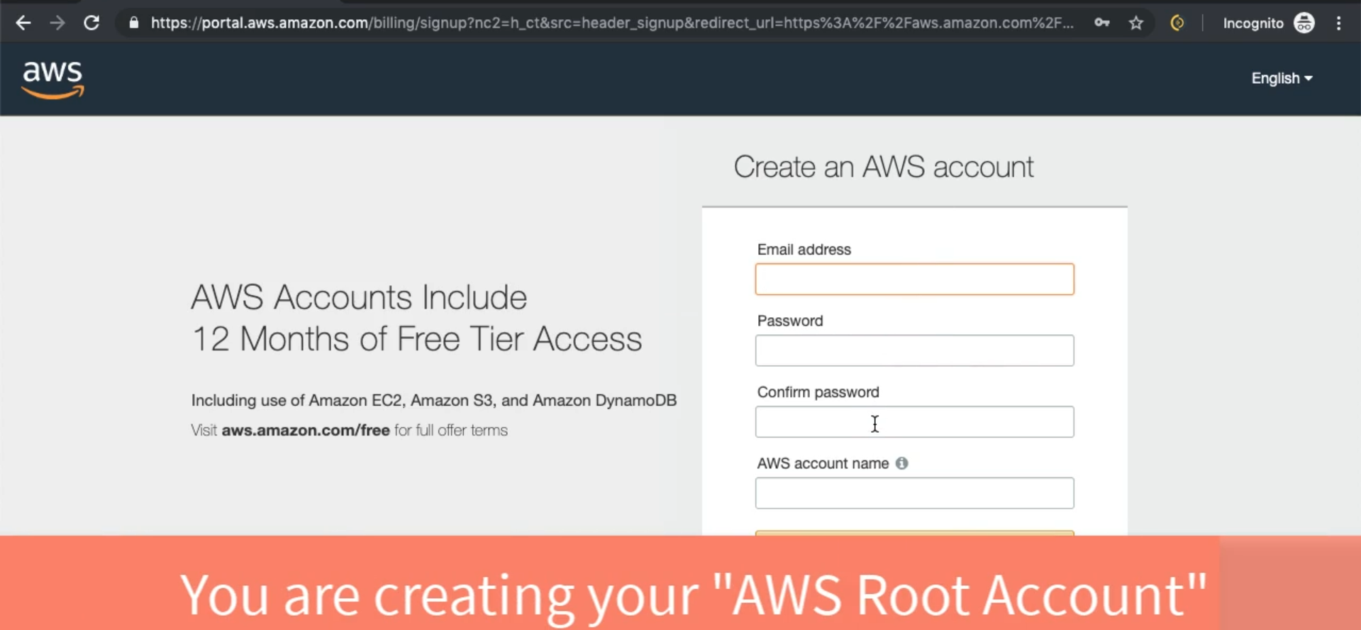
5. 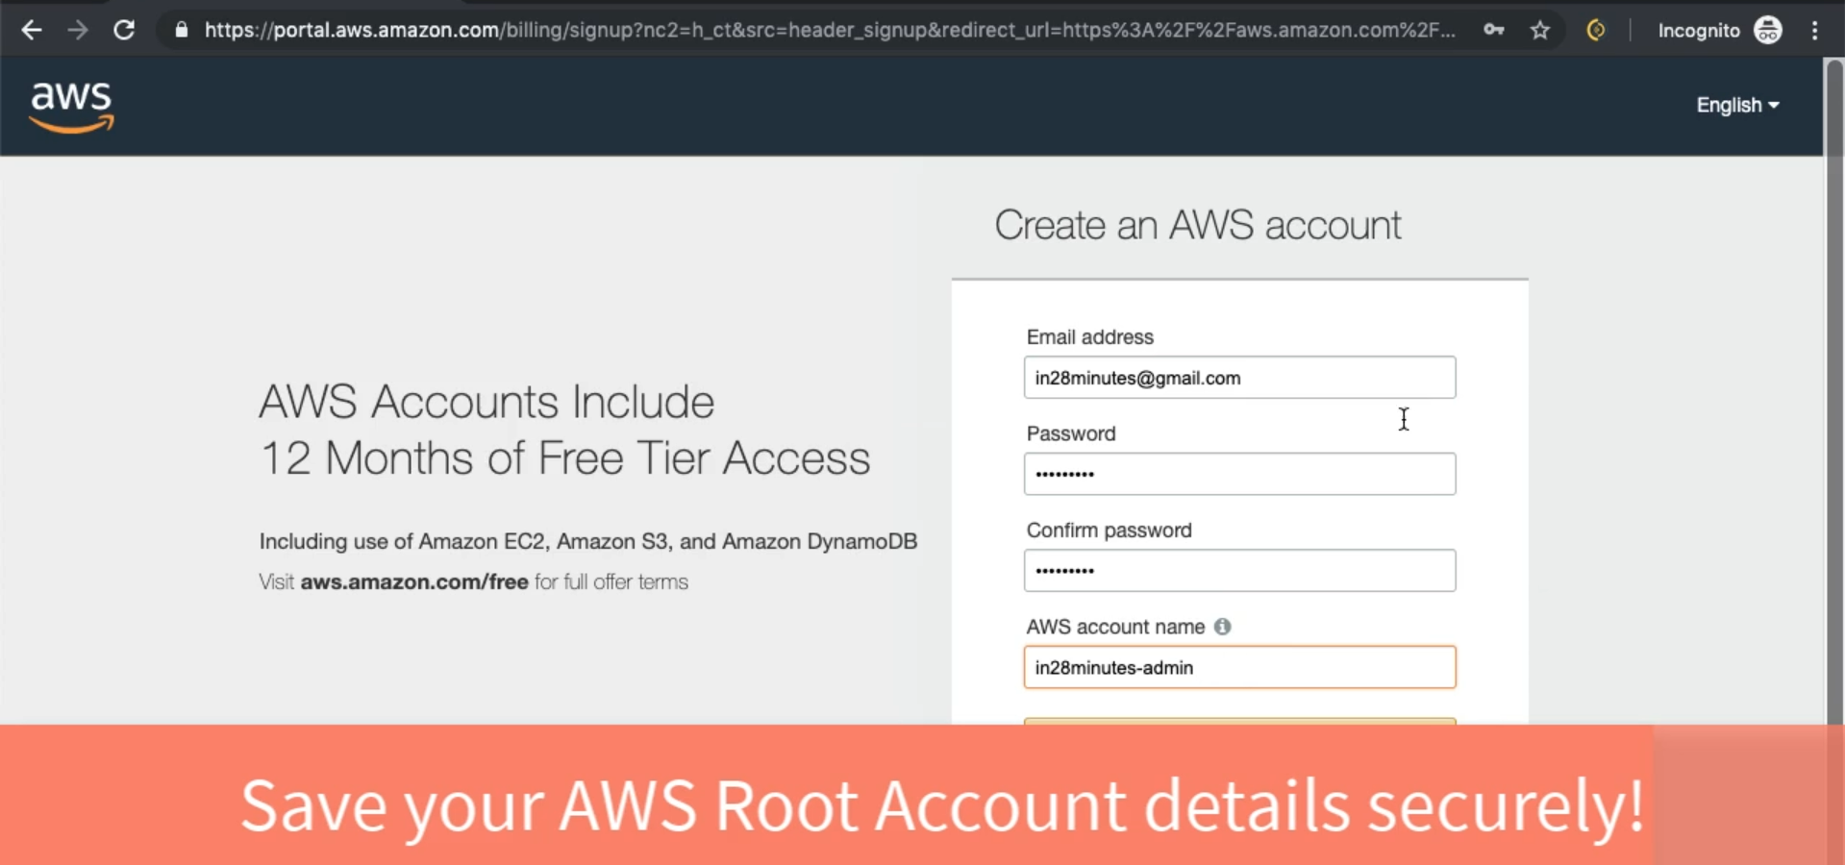
6. 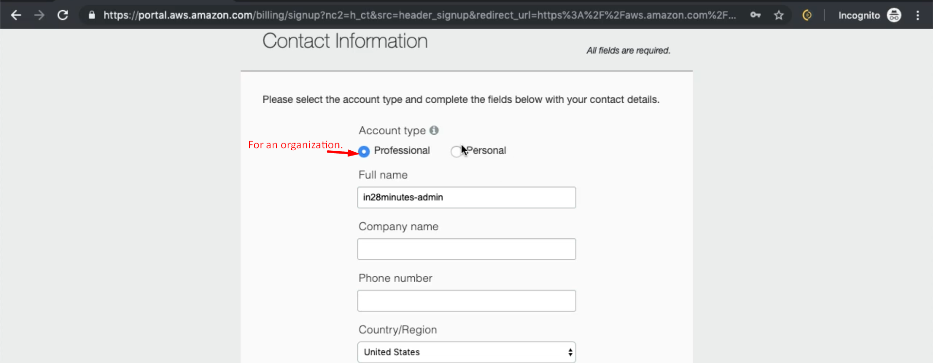
7. 
8. 
9. Let’s sign in  
   